1. wc
The wc command counts the number of lines, words, and bytes in a file.
It helps developers measure the size of text files and analyse log data.
Example:
wc -l notes.txt
This displays the number of lines in notes.txt.
2. cut
The cut command extracts specific sections or columns from each line of a text file.
It is useful for extracting fields from structured text, such as colon-separated system files.
Example:
cut -d ':' -f 1 /etc/passwd
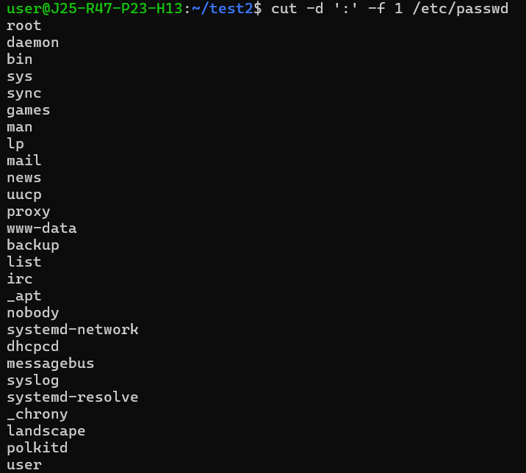
This displays the usernames listed in /etc/passwd.
3. uniq
The uniq command removes or identifies adjacent duplicate lines in sorted or grouped text.
It is useful for identifying repeated entries in logs and other text files.
Example:
sort names.txt | uniq
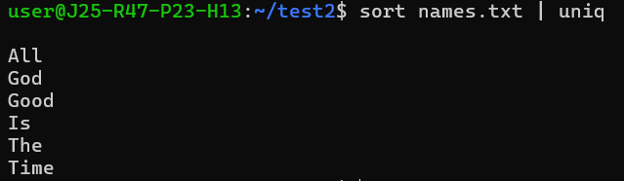
This sorts the names and displays each unique line once.
4. tee
The tee command displays command output on the terminal while also writing it to a file.
It is useful for saving troubleshooting output without losing the ability to view it immediately.
Example:
date | tee output.txt
This displays the date and saves the output in output.txt.
5. basename
The basename command extracts the final filename component from a file path.
It is useful in shell scripts when only a filename is needed instead of the full path.
Example:
basename /home/user/Documents/report.txt
Output:
report.txt
6. dirname
The dirname command extracts the directory portion of a file path.
It is useful in scripts for identifying the directory containing a file.
Example:
dirname /home/user/Documents/report.txt
Output:
/home/user/Documents
7. sleep
The sleep command pauses the execution of a command or shell script for a specified duration.
It is useful when scripts need to wait before performing the next operation.
Example:
sleep 5
This pauses the terminal command for five seconds.
8. file
The file command identifies the type of a file by examining its contents and format.
It helps determine whether a file is text, an image, an archive, or another file type.
Example:
file notes.txt
This displays the detected type of notes.txt.
9. stat
The stat command displays detailed information about a file or directory, including its size, permissions, and timestamps.
It is useful for checking file metadata during system administration and troubleshooting.
Example:
stat notes.txt
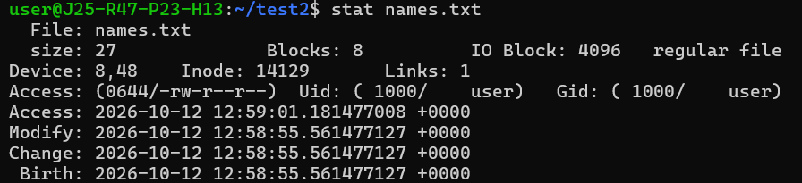
This displays detailed metadata for notes.txt.
10. hostname
The hostname command displays the system's host name.
It helps identify a machine when working with multiple Linux servers or cloud instances.
Example:
Hostname
This prints the current system's host name.

